Chocolate Dipped Bananas Food TV Rachael Ray
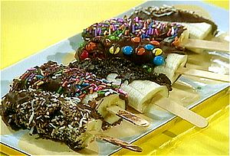

5 bananas
8 popsicle sticks
3 cups good quality chocolate bar
3 tablespoons butter, cut up

Toppings:
Chopped nuts
Cookie crumbles
Colored sprinkles or chocolate jimmies
Mini semi sweet chips, for chocoholics
Granola

Peel and cut the bananas in half crosswise, so that you have 8 pieces. Place peeled bananas on sticks. Line a cookie sheet with waxed paper. Place bananas on the cookie sheet in the freezer, keep them in there as long as possible, at least 10 minutes.

Heat chocolate bits with butter in a double boiler over low heat until the chocolate melts and butter is incorporated. Dip the chilled bananas in chocolate and roll with your favorite topping. Chill or freeze until ready to serve.

