Death by Chocolate Cookie Mary Stickney 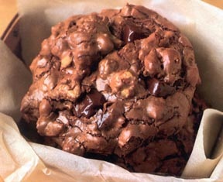

2 pkg (16 oz) Bakers Semi-Sweet Baking Chocolate, divided
¾ cup firmly packed brown sugar
¼ cup butter
2 eggs
1 tsp. Vanilla
½ cup flour
¼ tsp Baking Powder
2 cups chopped nuts

Heat oven to 350º

Coarsely chop I (8oz.) pkg of chocolate. Microwave the other pakg in large bowl on HIGH for 1-2 minutes. Stir chocolate until melted and smooth.

Stir in sugar, butter, eggs and vanilla.
Stir in flour and baking powder.
Stir in reserved chopped chocolate and nuts.

Drop cough by ¼ cup onto ungreased cookie sheet.

Bake 12 to 13 minutes or until cookies are puffed and feel set to the touch.
Cool on cookie sheet for 1 minute.
Transfer to wire rack to cool.

Makes about 1 ½ dozen.

