TAFFY TAN FUDGE
2 cups sugar
1 cup evaporated milk
1/2 cup butter
1-teaspoon vanilla
2 cups marshmallows
1 (12 ounce) jar chunky peanut butter
Combine sugar, milk, butter, and bring to a rolling boil. Stirring constantly, cook 15 minutes or longer until it forms a soft ball when tested in a cup of cold water. Remove from heat; add marshmallows, peanut butter, and vanilla. Blend well; pour into a buttered 9-inch square pan.
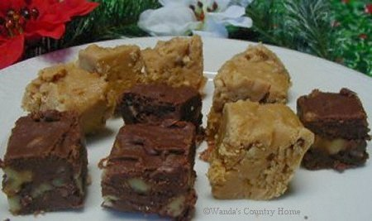
SEE'S FUDGE ~ TAFFY TAN FUDGE

SEE'S FUDGE
3 packages (6oz each) chocolate chips
1 (10-1/2 ounce bag) miniature marshmallows
1/2 pound butter
2 cups walnuts, broken in pieces
1 tablespoons vanilla
Place all of the above in a large bowl and then set aside. Bring to a boil 4-1/2 cups sugar and 1 large can evaporated milk. Stirring constantly, cook to a softball stage at 238 degrees, about 8 to 10 minutes. Stir with wooden spoon, pour over chocolate chip mixture, and mix well. Pour into a buttered 9x13 inch Pyrex. Let set until cool before cutting into squares.

