10 MINUTE PEANUT BRITTLE
1 cup sugar
1/2 cup light corn syrup
1/8 teaspoon salt
1 to 1-1/2 cups salted peanuts
1 tablespoon butter
1 teaspoon vanilla
1 teaspoon soda
In a 1 quart Pyrex measuring cup (the kind with a handle on it) mix sugar, syrup and salt. Microwave for 5 minutes on HIGH. Take out and stir in peanuts. Microwave 2 minutes on HIGH. Take out and stir, return to microwave and cook 2 more minutes until syrup and peanuts are lightly brown.
Stir in butter vanilla, baking soda and mix until light and foamy. Spread on a buttered cookie sheet to 1/4 inch thickness. (I use a glass Pyrex pizza pan) Makes 1 pound.
Note: Microwaves vary and the heating times you will need to play with and adjust to your microwave. My microwave heating times are: 4-1/2 minutes - 1-1/2 minutes - and 2 minutes.

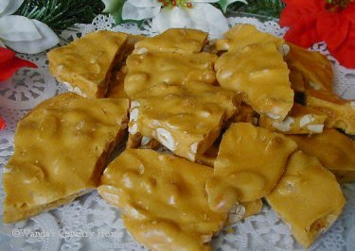
MICROWAVE PEANUT BRITTLE

