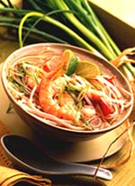
Thai Shrimp & Noodles
Frozen shrimp and a Thai seasoning blend make it possible to whip up this homemade soup in no time.

Yields: 8 cups or 4 main-dish servings
Total Time: 15 minutes
- 1 container (32 ounces) chicken broth
- 1 tablespoon Thai seasoning
- 4 ounces thin rice noodles (1/8 inch thick)
- 12 ounces fresh or frozen shelled and deveined raw shrimp
- 1/4 cup fresh lime juice
- 2 green onions, thinly sliced
- lime wedges (optional)
1. In 3-quart saucepan, heat broth, Thai seasoning, and 2 cups water to boiling over high heat.
2. Add rice noodles and shrimp; heat to boiling. Stir in lime juice and green onions. Serve with lime wedges.

